Reminder Application For Words And There Meaning On Desktop

**Ms. Satpute Pooja1, Ms. Gore Poonam2 ,Ms. Pawar Vishakha3, Ms. Jadhav Pranali4, Prof. Jadhav Swati 5**

Department Of Computer Engineering, Sahakar Maharshi Shankarrao Mohite Patil Institute Of Technology and Research Shankarnagar ,Akluj .

***Abstract –The increase of human activities has lead to the need of an activity reminder system. Now a days a mobile device has become daily communication device . An activity reminder system that runs on mobile device is more advantegous because the user does not need any additional device. Mobile device can be accessed anytime and anymore. This is a simple project in python progrmming . We learn to create a desaktop notification application in python in few steps. This app help in improving your English knowledge and notifying new one English word + pronunciation +Meaning in Marathi.***

***Keywords: Visual studio code, reminder system,***

***English words.***

**INTRODUCTION:**

This application will track time and show you notification after a brief period of time to remind you one English word+ Pronunciation + Meaning in Marathi. We are use *plyer*module to show the notification and the *time*module to run the module after a fixed period of time. We can install plyer by typing “**pip install plyer**” on the terminal/cmd. We are going to implement our own Reminder application with notification for desktop. Reminder application is a very simple application for pc and probably everyone have use this application at-least one time you learn one new English word withPronunciation +Meaning in Marathi. In this tutorial, we will create a simple Reminder application with notification. Reminder apps (applications) have played an important role in my life by supporting my academic career. The choices people have for spending time and the multiple pressures on time have increased the interest in tools for helping people to improving learning skills. First step we discussed on our chosen project topic, and then we researched on topic. After that starting worked on our project idea. Then we imported the packages in

python for the reminder application. Then we installed plyer

for notification and import time. We added some English

words + Pronunciation +Meaning in Marathi.

**LITERATUR SURVEY:**

We study several research papers on reminder application with notification and summarize below the findings. Reminder apps are useful when people need to remember tasks such as events deadlines and other routine obligations , but our project case we something different feature of project. We are using system time with plyer function. The main purpose of this study is to assess the at one time one new English word. This project provides an overview of reminder apps and their features. People often forget to perform everyday tasks, and they may find it difficult to recall details related to the tasks they have already completed. For example, people may fail to remember, or ‘forget’, future intentions such as they decide that should write a new word in the notebook or page every day but for some reason they can’t. So we try to implement this application.

**SYSTEM ARCHITECTURE:**

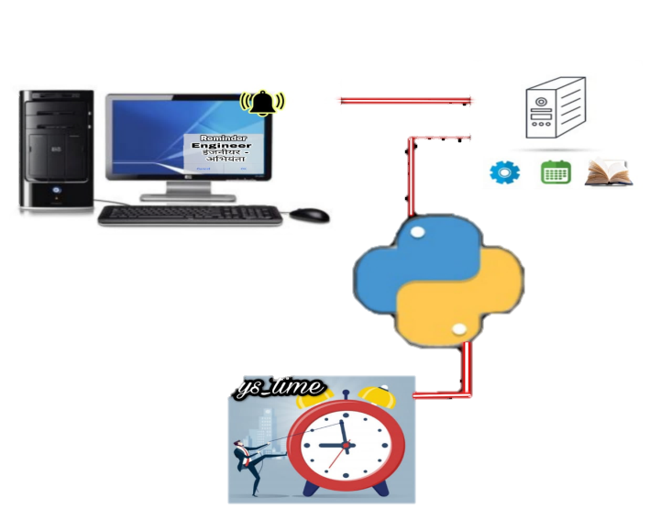

**METHODOLOGY:**

* We are going to implement our own Reminder application with notification for desktop. Reminder application is a very simple application for pc and probably everyone have use this application at-least one time you learn one new English word withPronunciation +Meaning in Marathi. In this tutorial, we will create a simple Reminder application with notification.
* Reminder apps (applications) have played an important role in my life by supporting my academic career. The choices people have for spending time and the multiple pressures on time have increased the interest in tools for helping people to improving learning skills.
* First step we discussed on our chosen project topic, and then we researched on topic. After that starting worked on our project idea. Then we imported the packages in python for the reminder application. Then we installed plyer for notification and import time. We added some English words + Pronunciation +Meaning in Marathi.

**OBJECTIVES:**

**FUTURE SCOPE:**

* In future we modify our application in android based application for mobile user .
* In future we use this application for notifying we for notes or like making sentence and also we add voice recognizer for words.

**CONCLUSION:**

* Our goal was to create an application where people lean new English word and improving knowledge.
* With the goals achieved the basis of application and this project has been achieved.
* Building this desktop application has been enriching because throughout the project we learnt lot about Python language.

**REFERENCES**

1. Borriello, G. & Holmquist, L. E. (2002). UbiComp 2002: Ubiquitous Computing: 4th International Conference, Göteborg, Sweden, September 29–October 1, 2002.
2. Proceedings. New York, NY: Springer Science & Business Media.
3. Buur, J. & Bagger, K. (1999). Replacing usability testing with user dialogue: How a Danish manufacturing company enhanced its product design process by supporting user participation. Communications of the ACM, 42(5), 63–66. Carter, P. (2007).
4. https://codewithharry.com/videos/python-practice-programs-in-hindi-6.
5. Experiential group learning for developing competencies in usability practice.
6. Empirical Software Engineering and Measurement, 2013 ACM/IEEE International Symposium on (pp. 15–24). IEEE. Kaikkonen, A., Kekäläinen, A., Cankar, M., Kallio, T. & Kankainen, A. (2005).
7. https://github.com/atozknowledge/python/tree/maste.
8. Usability testing of mobile applications: A comparison between laboratory and field testing. Journal of Usability Studies, 1(1), 4–16. Kim, J., Park, Y., Kim, C. & Lee, H. (2014). Mobile application service networks: Apple’s app store. Service Business, 8(1), 1–27.
9. Krumm, J. C. & Hughes, R. L. (2006). U.S. Patent Application 11/462,885. Laurel, B. (2003). Design research: Methods and merspectives. LA: MIT Press. Leung, N., Nkhoma, M. & John, B. (2013). Proceedings of the 4th International Conference on IS
10. Management and Evaluation: ICIME 2013. UK: Academic Conferences Limited.